**ET380模拟器使用说明**Instructions Of ET380 Debug

# 1 准备工作Ready to work

数据线 Android Data Cable

ET380 Device

ETEmulator.exe工具 ETEmulator.exe Tool

# 2 使用说明Instructions for use

点击【Start】按钮,PC即可连上ET380终端。Select COM port of ET380 Device(ignore the Virtual one),Click the [Start] button, and the PC can connect to the ET380 terminal.

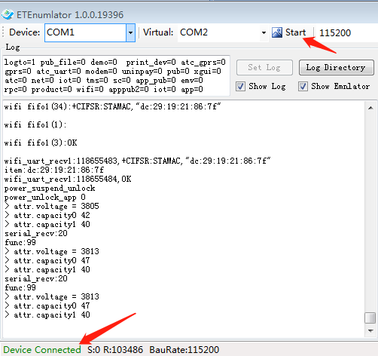

**2.3,打开日志**

在Log日志输入窗口输入数据：Enter follow data in the Log input window:

logto=1 pub_file=0 demo=0 print_dev=0 atc_gprs=0 gprs=0 atc_uart=0 modem=0 uninpay=0 pub=0 xgui=0 atc=0 net=0 iot=0 tms=0 sc=0 app_pub=0 emv=0 rpc=0 product=0 wifi=0 apppub2=0 iot=0 app=0

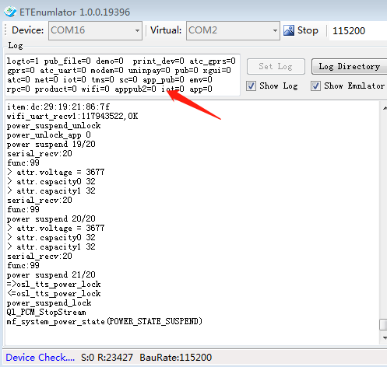

数据输入完成，点击【Set Log】按钮，终端自动重启后即可输出终端日志。After data input is complete, click the [Set Log] button, and the terminal will automatically restart to output the terminal log.

